Student Affairs Planning, Assessment & Research
Organizational Chart

Director
Darby Roberts, Ph.D.

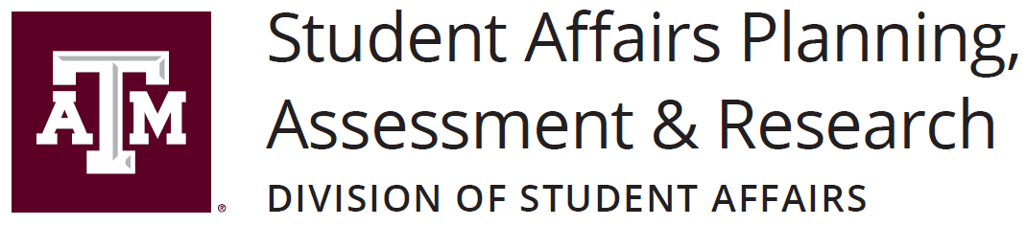
Coordinator for
Student Learning
Frankie Jackson
Assistant Director
Susan Fox-Forrester
Data
Analyst
Robert Tirso, Ph.D.
Program Coordinator/ Assessment Coordinator
Gabrielle Tharp
Program Coordinator/ Assessment Coordinator
Vacant
Associate Director
Kelly Cox

January 2024

